Name
Instructor
Course
Date

Name: Stacy Evans
Date of Assessment: 1/1/2016

Target Behavior: Tantrum

RESULTS OF FUNCTIONAL ANALYSIS FOR STACY

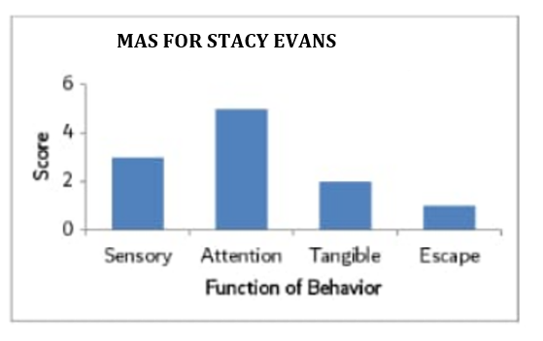

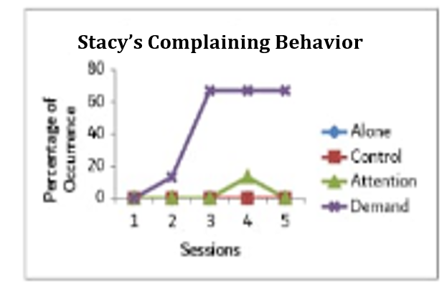

ALONE CONDITION

 | 0-9 seconds | 10-19 seconds | 20-29 seconds | 30-39 seconds | 40-49 seconds | 50-59 seconds | Percentage of Intervals
Minute 1 | -- | -- | -- | -- | -- | -- | 0%
Minute 2 | -- | -- | -- | -- | -- | -- | 0%
Minute 3 | -- | -- | -- | -- | X | -- | 17%
Minute 4 | -- | -- | -- | -- | -- | -- | 0%
Minute 5 | -- | -- | -- | -- | -- | -- | 0%

ATTENTION CONDITION

 | 0-9 seconds | 10-19 seconds | 20-29 seconds | 30-39 seconds | 40-49 seconds | 50-59 seconds | Percentage of Intervals
Minute 1 | -- | -- | -- | -- | -- | -- | 0%
Minute 2 | -X | X | -- | -- | -- | -- | 33%
Minute 3 | -- | -- | -- | -- | -- | -- | 0%
Minute 4 | -- | -- | -- | -- | -- | -- | 0%
Minute 5 | -- | -- | -- | -- | -- | -- | 0 %

BE SURE TO CALCULARE THE PERCENTAGE OF INTERVALS FOR THE PLAY AND ESCAPE CONDITION BELOW. THE PERCENTAGE OF INTERVALS SHOULD BE CALCULATED BELOW. THE ATTENTION AND ALONE CONDITION CHART ABOVE CAN BE USED AS AN EXAMPLE OF HOW TO CALCULATE THE PERCENTAGE OF INTERVALS.

PLAY CONDITION
 | 0-9 seconds | 10-19 seconds | 20-29 seconds | 30-39 seconds | 40-49 seconds | 50-59 seconds | Percentage of Intervals
Minute 1 | -- | -- | -- | -- | -- | -- | 0%
Minute 2 | -- | -- | -- | -- | -- | -- | 0%
Minute 3 | -- | -- | -- | -- | -- | -- | 0%
Minute 4 | -- | -- | -- | -- | -- | -- | 0%
Minute 5 | -- | -- | -- | -- | -- | -- | 0%

ESCAPE CONDITION

 | 0-9 seconds | 10-19 seconds | 20-29 seconds | 30-39 seconds | 40-49 seconds | 50-59 seconds | Percentage of Intervals
Minute 1 | -- | -- | X | X | -- | -- | 33%
Minute 2 | X | -- | -- | -- | -- | -- | 17%
Minute 3 | -- | -- | -- | X | -- | -- | 17%
Minute 4 | X | X | X | -- | X | -- | 67%
Minute 5 | X | X | X | -- | X | X | 84%

Stacy has five triggers that lead her to have tantrums. The trigger that causes the most practices is when requests are set on Stacy, for example, non-preferred engagements or activities, for example, scrubbing down or when requested to eat her vegetable by parents. Tantrums likewise happen when Stacy is changing from what she likes to what she does not like. There is a high rate of practices when Stacy needs access to unmistakable things, similar to food, and toys. For instance, if the parents reveal to her that she can't carry the teddy bear while interacting with others from the community. Half of the time the tantrum when ceasing if Stacy is offered access to the things she needs.

